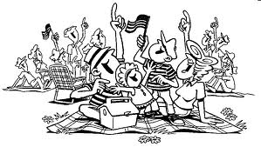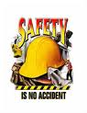

**Semper Safe**

**FIREWORKS** – **ENJOY A SAFE 4**th **OF JULY**

[](http://www.google.com/imgres?imgurl=http://2.bp.blogspot.com/-yL-w2oAxO4c/ThOPwt5rOyI/AAAAAAAAAOA/4Tv5EA0NyeY/s1600/liberty-fireworks.jpeg&imgrefurl=http://jessicalynn-mylondonadventures.blogspot.com/2011/07/4th-of-july-in-londonnon-eventful.html&usg=___FeGe0YkRjHAsneHvNokWdIS3JI=&h=369&w=400&sz=72&hl=en&start=13&zoom=1&tbnid=TGh8m63NjdER7M:&tbnh=114&tbnw=124&ei=lmnsT--vM-WW6AH-jrC9BQ&prev=/search?q=4th+of+july&um=1&hl=en&sa=N&gbv=2&tbm=isch&um=1&itbs=1)

With the Fourth of July holiday period this weekend, neighbors will be gathering, barbecues will be going, and fireworks will light the sky to celebrate our independence. It is important to take safety measures to avoid the bursts of purple and green turning into a red and white ambulance strobe.

Although fireworks are a fun and exciting way to celebrate our nation’s freedom, they can also be harmful or even deadly if not used properly. Malfunctions and careless use of fireworks resulted in 9600 injuries in 2011. More than 65 percent of all fireworks-related injuries occur during the month of July. Of those, more than half are to the hands, fingers, and eyes. The most common fireworks that cause injury are firecrackers, bottle rockets, Roman candles, fountains, and sparklers that are legal in many states.

The Consumer Product Safety Commission and National Council on Fireworks Safety offer the following fireworks safety tips and information:

* **Did you know lit sparklers can reach temperatures up to 2,000 degrees Fahrenheit? Be cautious to not catch clothes on fire.**
* **Parents should pay special attention to children using sparklers, which can cause serious injury if not handled correctly.**
* **Only use fireworks outdoors.**
* **Read and follow all warnings and instructions before igniting fireworks.**
* **Obey all local laws regarding the use of fireworks.**
* **Ensure that spectators are out of the range of the fireworks, bystanders are more frequently injured by fireworks than the people who are using them!**
* **Only light fireworks outside on a smooth, flat surface away from the house and flammable materials, avoid using fireworks near dry leaves or grass altogether.**
* **Never try to relight fireworks that did not go off.**
* **Always have a bucket of water, or water hose, nearby.**
* **Alcohol and fireworks never mix!**
* **If an injury occurs, stay calm. If your clothing catches on fire, lie on the ground, cover your face with your hands, and roll.**
* **If you get something in your eye from a fireworks explosion, don’t rub or rinse your eye. Have your friends or family take you to the emergency room immediately.**

For more information on firework safety visit: [**www.fireworksafety.com**](http://www.fireworksafety.com).

North Carolina prohibits the following for home firework celebrations: **Explosive or aerial fireworks, roman candles, and rockets or similar devices.**

***As Marines, Sailors and Civil Servants we live by our core values. So think before you jeopardize the safety of yourself, your fellow Marines, Sailors, civilian employees or family******members, and remember SEMPER SAFE!***   
 SS 12-05

**Semper Safe**

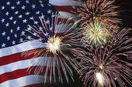

**Our advice: Go out, relax and let**

**someone else do the dangerous work**

**while you sit back and enjoy.**

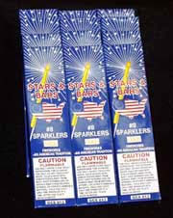

***As Marines, Sailors and Civil Servants we live by our core values. So think before you jeopardize the safety of yourself, your fellow Marines, Sailors, civilian employees or family members, and remember SEMPER SAFE***

SS 12-05

